1. d
2. We can externalize the configuration using Spring Profile Mechanism and the way we supply it is through the application.properties or application.yaml file.
3. 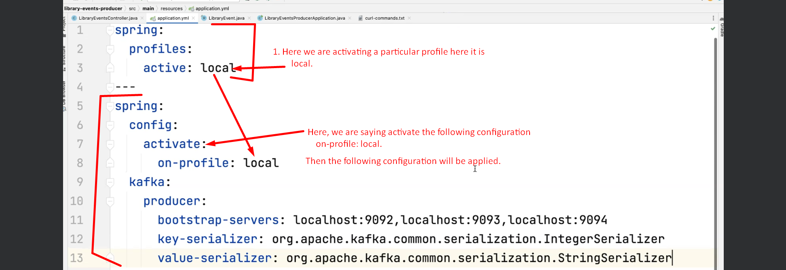
4. 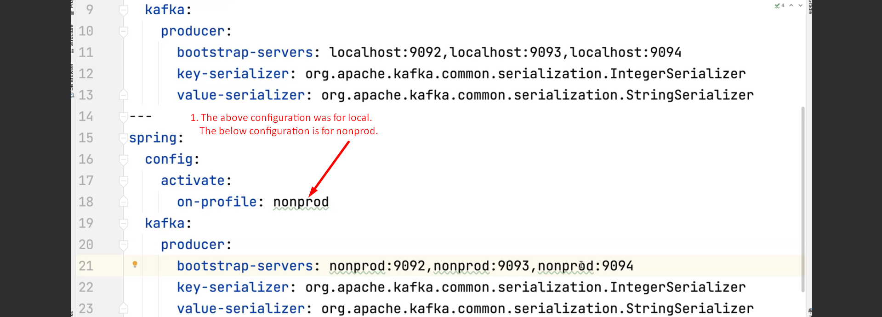
5. It is better to put a specific environment configuration in its own file like
   1. Local configuration into application-local.yaml.
   2. nonprod configuration into application-nonprod.yaml.